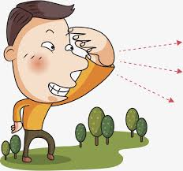  Distance  How far is your house from here? |   Age  How old is your granddad? |   Quantity ( countable nouns)  How many people are here?
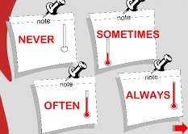  Frequency  How often do you dance? | 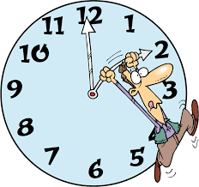  Period of time  How long does it take you to go to work? | 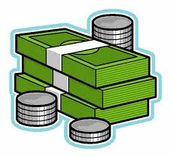  Quantity (uncountable nouns)  How much is the car?
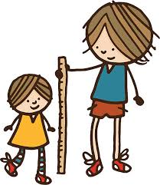  High  How tall are you? |   High  How high is the Mount Everest? |   Depth  How deep is the ocean?
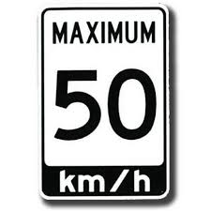  Speed  How fast can you drive here? | 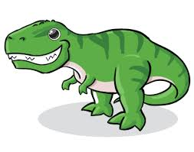  Size  How big was a dinosaur? | 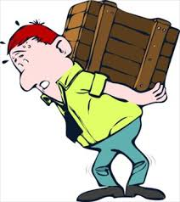  Weight  How heavy is the box?

